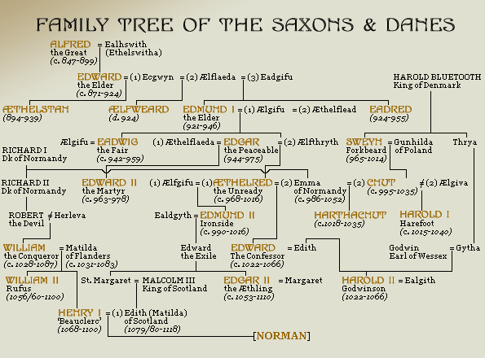
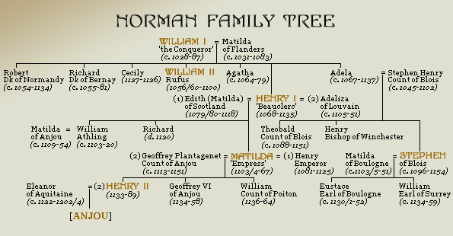
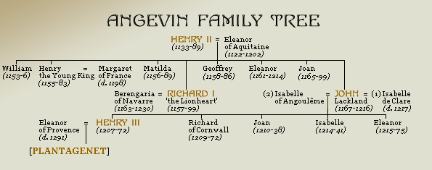
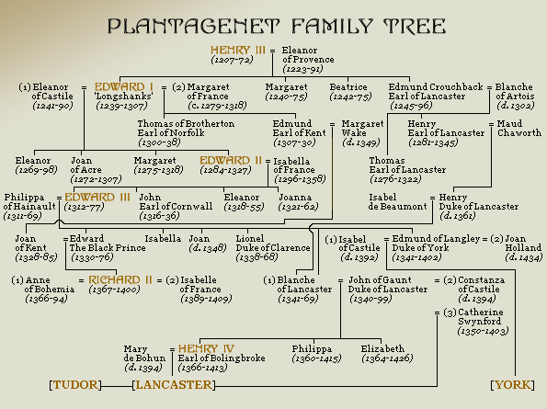
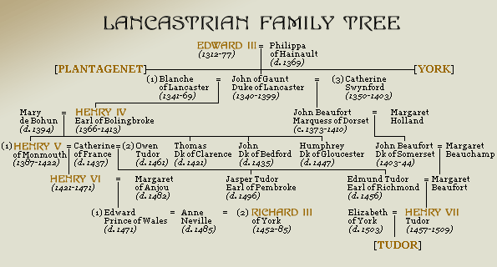
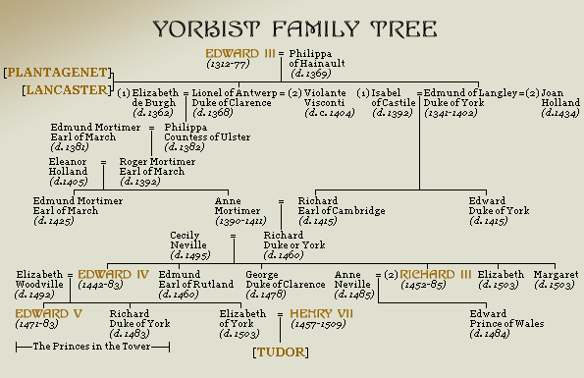

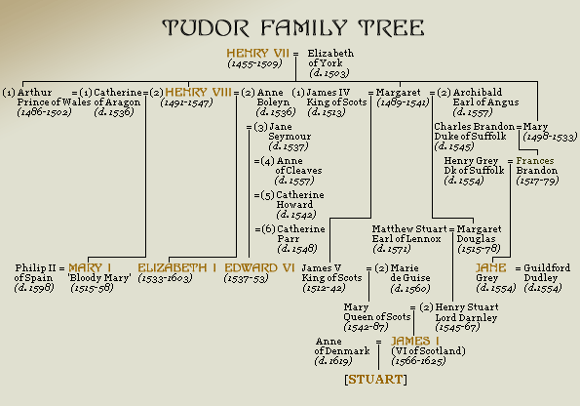

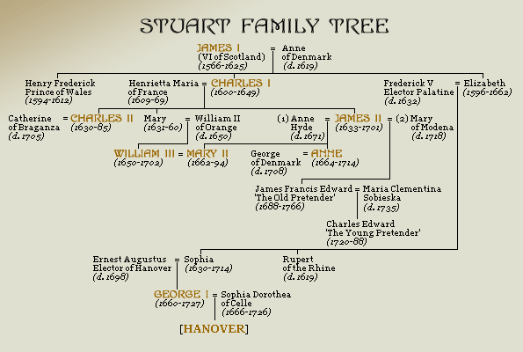
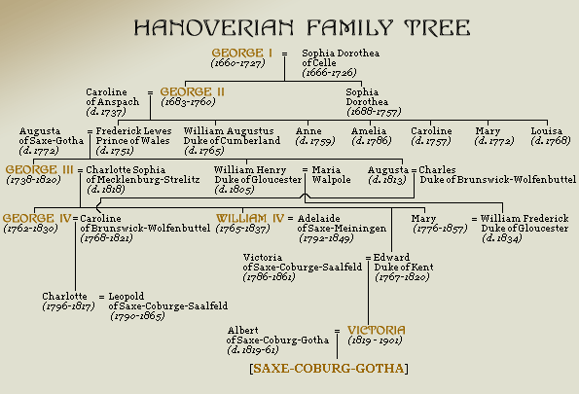
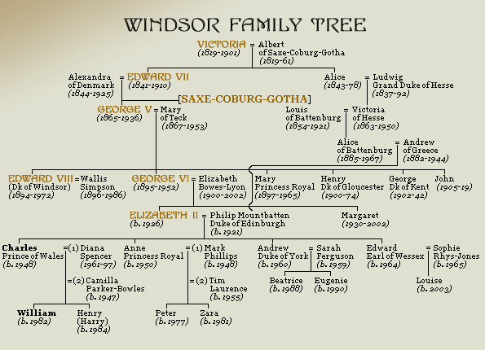

NORMAN DYNASTY
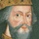 | WILLIAM I | 1066 - 1087 | 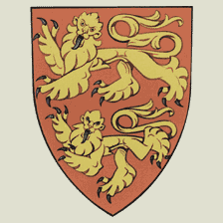
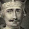 | WILLIAM II | 1087 - 1100
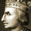 | HENRY I | 1100 - 1135
 | STEPHEN | 1135 - 1141  1141 - 1154
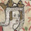 | MATILDA | 1141
ANGEVIN DYNASTY
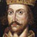 | HENRY II | 1154 - 1189 | 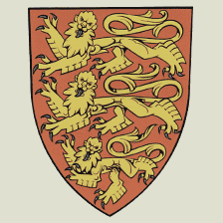
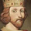 | RICHARD I | 1189 - 1199
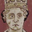 | JOHN | 1199 - 1216

PLANTAGENET DYNASTY
 | HENRY III | 1216 - 1272 | 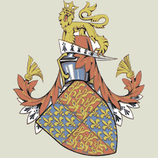
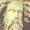 | EDWARD I | 1272 - 1307
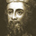 | EDWARD II | 1307 - 1327
 | EDWARD III | 1327 - 1377
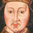 | RICHARD II | 1377 - 1399
LANCASTRIAN DYNASTY
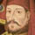 | HENRY IV | 1399 - 1413 | 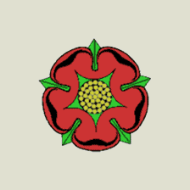
 | HENRY V | 1413 - 1422
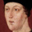 | HENRY VI | 1422 - 1461  1470 - 1471

YORKIST DYNASTY
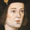 | EDWARD IV | 1461 - 1470  1471 - 1483 | 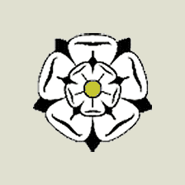
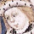 | EDWARD V | 1483
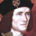 | RICHARD III | 1483 - 1485
TUDOR DYNASTY
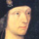 | HENRY VII | 1485 - 1509 | 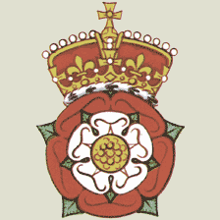
 | HENRY VIII | 1509 - 1547
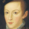 | EDWARD VI | 1547 - 1553
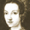 | JANE | 1553
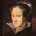 | MARY I | 1553 - 1558
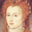 | ELIZABETH I | 1558 - 1603

STUART DYNASTY
 | JAMES I | 1603 - 1625 | 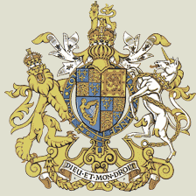
 | CHARLES I | 1625 - 1649
 | INTERREGNUM  ^{(MONARCHY ABOLISHED)} | 1649 - 1660
 | CHARLES II | 1660 - 1685
 | JAMES II | 1685 - 1688
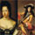 | MARY I & WILLIAM III  ^{(JOINTLY)} | 1689 - 1694
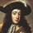 | WILLIAM III  ^{(ALONE)} | 1694 - 1702
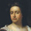 | ANNE | 1702 - 1714
HANOVERIAN DYNASTY
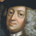 | GEORGE I | 1714 - 1727 | 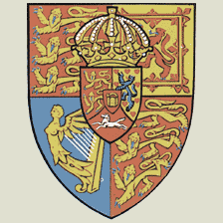
 | GEORGE II | 1727 - 1760
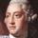 | GEORGE III | 1760 - 1820
 | GEORGE IV | 1820 - 1830
 | WILLIAM IV | 1830 - 1837
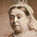 | VICTORIA | 1837 - 1901

SAXE-COBURG-GOTHA DYNASTY
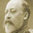 | EDWARD VII | 1901 - 1910 | 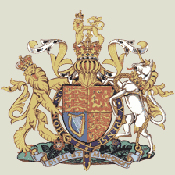
WINDSOR DYNASTY
 | GEORGE V | 1910 - 1936
 | EDWARD VIII | 1936
 | GEORGE VI | 1936 - 1952
 | ELIZABETH II | 1952 - PRESENT

